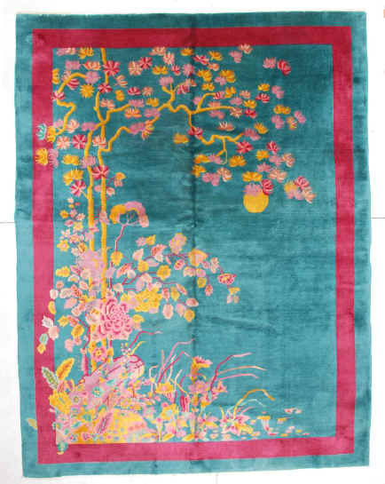

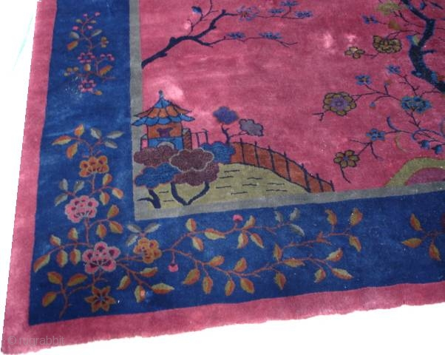

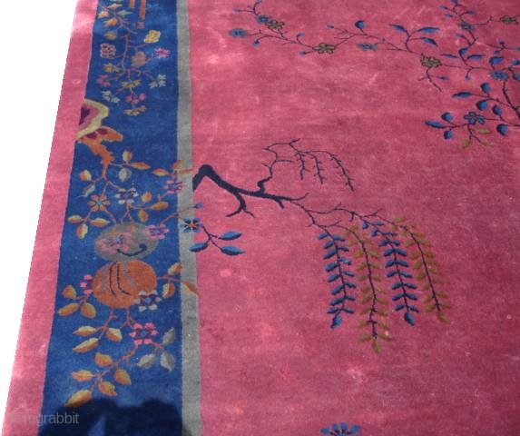



[Click to show "chinese dragon" result 7](http://www.picsearch.com/imageDetail.cgi?id=qPiAfHjGdtFUURxdTtZLv42DI1Vp7928iDNJIcr1K9I&width=1260&start=61&q=chinese%20dragon)