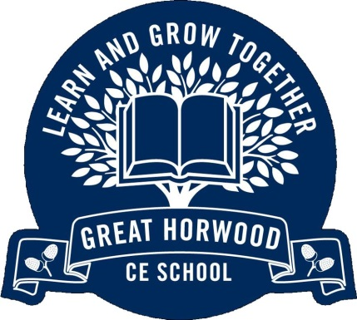

**Useful Information**

P.E. kit is needed in school every day. Our usual days for P.E. are Monday and Thursday.

Diary homework is due in on Monday. Spellings are set and tested each Monday. Maths work may be weekly completion of CGP or personalised worksheets.

Please make sure your child reads **every day**, practises multiplication tables and weekly spellings.

Weekly spellings are available on the school website homepage.

Children may bring a bottle of water to school. Children may also bring a healthy snack of fresh or dried fruit to eat at break time.

When it is Year 6’s turn (monthly) to care for the chickens they should bring in outdoor shoes. If you shred paper at home we would be happy for a couple of bags of shreddings to use as bedding. Children may also bring in non-meat kitchen scraps from home to feed the chickens.

Great Horwood

Church of England Combined School

**Year Six**

Curriculum Overview

Summer Term 2015

The Victorians

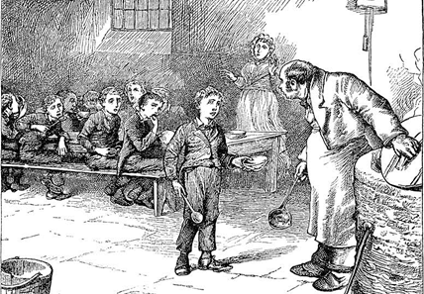

**Mathematics**

We will be consolidating and developing children’s knowledge and skills in maths across all areas. SATs revision will be a focus at the beginning of the term. Later on, we will be conducting mathematical investigations

***How can I support my child?***

Please support your child to practice their times tables regularly until they are completely secure in all facts to 12x12.

Children must be able to identify when they need to use different operations in word problems, and to complete these using *standard written methods.*

**English**

Text: Oliver Twist

* Biographies/ Autobiographies
* Persuasive Writing
* Revision of all writing genres
* Revision of Spelling, Punctuation and Grammar

***How can I support my child?***

Please ensure that your child is still reading every day. This of course improves reading skills and comprehension in all subjects, but it also is the key factor to children attaining high levels of writing at the end of KS2

**PSHCE**

We are going to ‘be our best’ and then consider what is great about me before preparing for the transition to secondary school in the summer.

**Religious Education**

**Can we know what God is like?** Looking at all world religions, but particularly Sikhism and Christianity we will look at this question and see what the answer is for different religions.

**Does it matter what we believe about creation?** What do different religions believe about creation. Does it influence how we treat the environment?

**Science**

This term in science we will be looking at the concept of light travelling in straight lines, how opaque objects cause shadows, and how light is reflected. We will then look at how rainbows form colours. Before the summer we will study electricity and how we can modify circuits and then conclude with a week about dinosaurs where will be further develop our science enquiry skills.

**Physical Education**

* Basketball
* Athletics

**French**

All about me!

**British Values**

The fundamental British values are ***democracy, the rule of law, individual liberty and mutual respect and tolerance of those with different faiths and beliefs.*** Year 6 pupils will explore, reflect and demonstrate these values through topic lessons, RE, PSHE, shared worship and their daily conduct across the school, ensuring that they set the example for the rest of the school.

**Computing**

Creating and developing our own apps.

**Curriculum Theme : The Victorians**

**(Geography, History, Art, Design and Technology and Music)**

* Victorian childhood
* Victorian London
* William Morris art
* 200 years of biscuits
* Oliver!

**Christian Values**

This term’s values are Trust and Respect.

**Respect:** Year 6 children set the example to the rest of the school by demonstrating respect to others, including adults and other children, and to themselves in always trying their best and showing pride in their presentation.

**Trust:** Year 6 children will reflect on trust and how they can be trustworthy pupils and classmates.