GREAT HORWOOD C.E. COMBINED SCHOOL
SCHOOL END, GREAT HORWOOD, BUCKS MK17 0RG
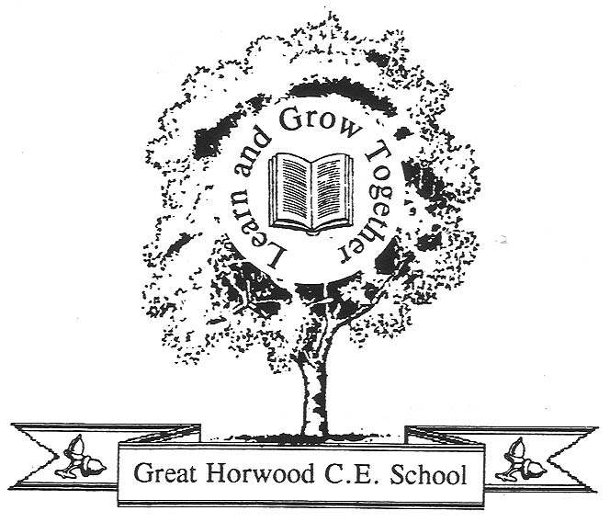
Headteacher: Paul Adams Email:office@greathorwood.bucks.sch.uk
Telephone: (01296) 712622

Fax: (01296) 713968
School Web Site:www.greathorwood.bucks.sch.uk

23rd January 2012

Dear Parents,

As a whole class reward for good behaviour, children in Years 5 and 6 have earned an extra mufti day. As a result, the children can come to school on Friday 27th January in non school uniform.

Yours sincerely

Mrs K Standen
Class Teacher





